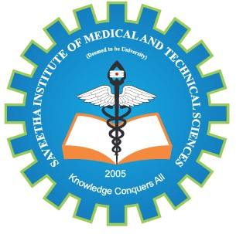
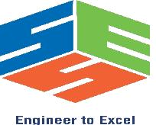
SIMATS ENGINEERING

Saveetha Institute of Medical and Technical Sciences
Chennai- 602105

Student Name: VISHALI P Reg. No.: 192524313
Course Code: CSA0974 Slot: C
Course Name: Java programing
Course Faculty: Dr.R.Mohan and Dr.Meganathan
Project Title: AI-Powered Resume Screening and Candidate Ranking System
Module Photographs: (3 photographs –Module Photo, Individual student contribution module work in the project and presentation image)
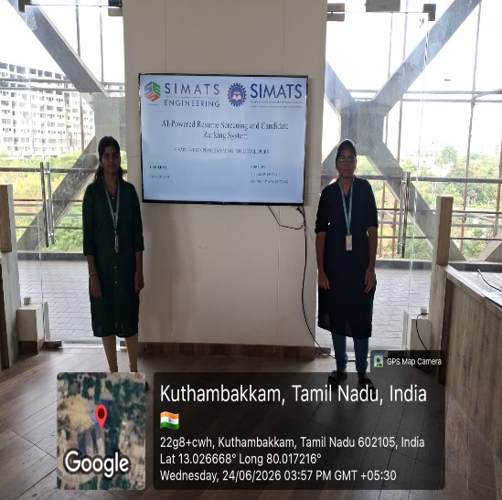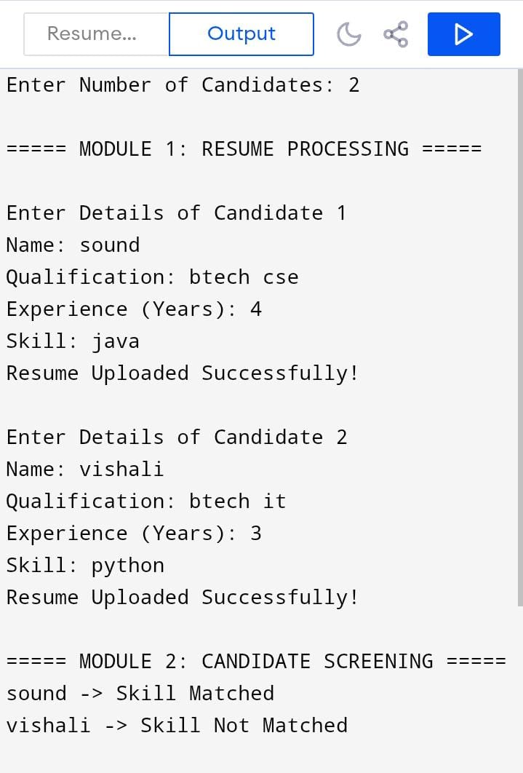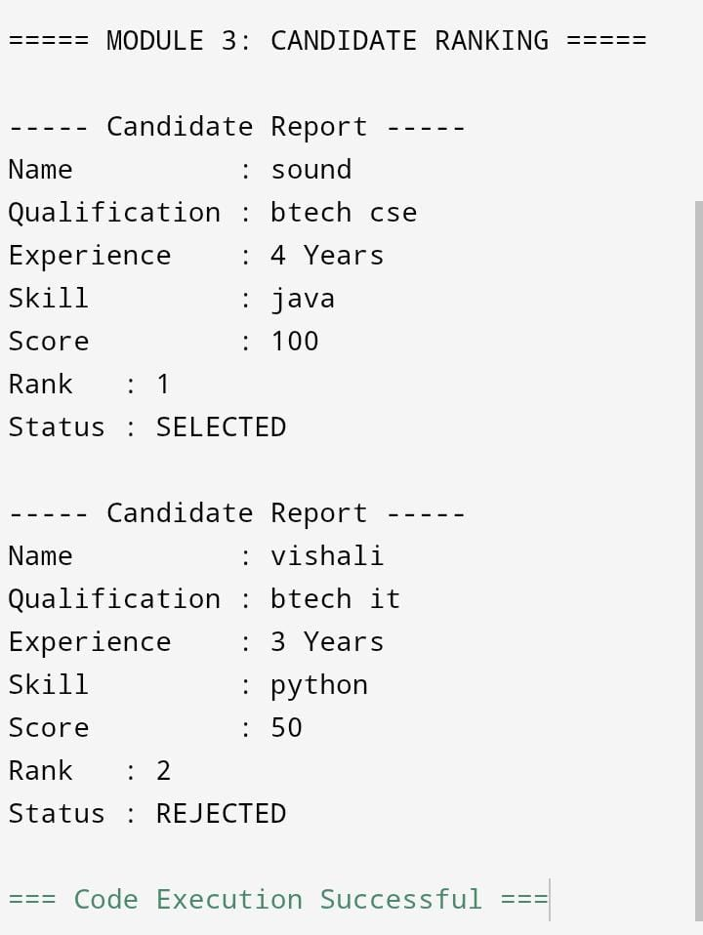
Project Description: (here you write what you did in this project (contribution) including Model
Description

The AI-Powered Resume Screening and Candidate Ranking System is a smart recruitment solution that uses Artificial Intelligence (AI), Machine Learning (ML), and Natural Language Processing (NLP) to automate the hiring process.
The system analyzes resumes, extracts important information such as skills, education, experience, and certifications, and compares it with the job requirements provided by recruiters.
Based on the matching score, candidates are ranked according to their suitability for the job.
This helps organizations reduce manual screening efforts, save time, improve hiring accuracy, and efficiently manage large numbers of job applications while supporting fair and data-driven recruitment decisions.

Student Signature Guide Signature

